☕
AFFICIONADO COFFEE ROASTERS
Sales Trend & Time-Based Performance Analysis

Exploratory Data Analysis Report
Covering: EDA | SQL Analysis | Excel Pivot Insights | Operational Recommendations

Locations Analysed: Astoria · Hell’s Kitchen · Lower Manhattan
Dataset Period: 2026 Transactions · Total Revenue: $698,812.33
Tools Used: Google BigQuery (SQL) · Microsoft Excel · Python / Streamlit / Plotly

Table of Contents
1. Background & Context
2. Problem Statement
3. Project Objectives
4. Dataset Description
5. Analytical Methodology
6. Exploratory Data Analysis (EDA)
6.1 Revenue Overview
6.2 Hourly Busyness Analysis (Excel)
6.3 Revenue per Store Location (Excel)
6.4 Revenue by Product Category (Excel)
7. SQL Analysis & Query Results
7.1 Query 1 – Revenue & Quantity by Location, Category, and Shift
7.2 Query 2 – Hourly Foot Traffic per Store
7.3 Query 3 – Price Tier Analysis by Product Category
8. Key Findings & Insights
9. Operational Recommendations
10. Conclusion

1. Background & Context

In specialty coffee retail, when sales occur is just as important as what is sold. Afficionado Coffee Roasters operates three retail locations across New York City — Astoria, Hell’s Kitchen, and Lower Manhattan — each serving a distinct customer demographic with different commuting patterns, work schedules, and lifestyle habits.

Despite generating $698,812.33 in total revenue from 149,116 transactions in 2025, the business has historically lacked a consolidated, data-driven framework to understand temporal demand patterns. Operational decisions around staffing, operating hours, and promotional timing have largely been experience-driven rather than evidence-based.

Poor understanding of temporal demand patterns can result in:
- Overstaffing during slow hours, increasing labour costs without proportional revenue benefit
- Understaffing during rush periods, leading to longer queues and customer dissatisfaction
- Inconsistent customer experience across shifts and locations
- Missed upselling and promotional opportunities during peak windows
- Inefficient alignment between product stock levels and actual demand cycles

This report uses transaction-level data, SQL-based aggregations on Google BigQuery, and Excel pivot analysis to surface the quantitative evidence needed to address these gaps.

2. Problem Statement

Despite having transaction-level data available, Afficionado Coffee Roasters currently lacks:
- A consolidated view of sales trends across time periods and shifts
- Clear identification of peak and off-peak hours and days
- Hourly demand insights broken down across different store locations
- A quantitative framework to compare store performance on a shift-by-shift basis
- An understanding of which product categories drive the most volume and revenue

Without structured analytics, the business cannot answer critical operational questions such as: Which shift should receive maximum staffing? Which location has the highest foot traffic at 9:00 AM? What proportion of revenue comes from the Morning shift? Are standard-priced products outperforming premium ones in terms of volume?

3. Project Objectives

Primary Objectives
- Identify overall sales trends across 2025 transaction data
- Determine the busiest and slowest operational shifts (Morning, Afternoon, Evening)
- Identify peak transaction hours across all three store locations

Secondary Objectives
- Compare temporal demand patterns across Astoria, Hell’s Kitchen, and Lower Manhattan
- Support data-driven staff scheduling and operational planning
- Analyse product category and price tier performance
- Provide evidence-based explanations for observed sales patterns

4. Dataset Description

The dataset consists of granular transaction records from all three Afficionado Coffee Roasters stores for the 2025 calendar year. The table below describes each column:

Column | Description
transaction_id | Unique identifier per transaction
year | Transaction year (2025)
transaction_time | Time of transaction (HH:MM:SS format)
transaction_qty | Quantity of items purchased in the transaction
unit_price | Price per unit of the product
store_id | Numeric store identifier
store_location | Physical store location name (Astoria, Hell’s Kitchen, Lower Manhattan)
product_id | Unique identifier for each product SKU
product_category | Broad product group (e.g., Coffee, Tea, Bakery)
product_type | Product variant within the category
product_detail | Detailed attributes such as flavour or blend
Day_Shifts | Derived shift label: Morning (6–11), Afternoon (12–16), Evening (17–21)
Revenue_generated | Derived column: transaction_qty × unit_price

Total records: 149,116 transactions | Total revenue: $698,812.33 | Unique stores: 3

5. Analytical Methodology

5.1 Data Ingestion & Validation
- Loaded the transaction dataset from CSV into both Excel and Google BigQuery
- Validated timestamp formats (HH:MM:SS) using EXTRACT(HOUR FROM TIME(...)) in BigQuery
- Checked for missing values and logical consistency (positive quantities and prices)
- Verified transaction IDs for duplicates; confirmed no critical data quality issues

5.2 Feature Engineering
The following derived features were created for temporal analysis:
- Revenue per transaction: transaction_qty × unit_price
- Hour of day (0–23): extracted from transaction_time
- Day_Shifts time buckets: Morning (6–11), Afternoon (12–16), Evening (17–21), Late hours (22–5)

5.3 Analysis Layers
- Excel Pivot Tables: shift-level transaction counts and revenue aggregations per store
- Google BigQuery SQL: cross-dimensional aggregations for revenue, foot traffic, and price tiers
- Streamlit Dashboard: interactive visualisation layer built with Python and Plotly

6. Exploratory Data Analysis (EDA)

6.1 Revenue Overview
The following table summarises the high-level performance metrics derived from the full 2025 dataset:

Metric | Value
Total Revenue | $698,812.33
Total Transactions | 149,116
Average Revenue per Transaction | ~$4.69
Top Revenue Store | Hell’s Kitchen ($236,511.17)
Top Product Category | Coffee ($269,952.45)
Busiest Shift (by transactions) | Morning (81,751 transactions)
Busiest Shift (by revenue) | Morning ($388,288.67)

6.2 Hourly Busyness Analysis (Excel Pivot)
The Excel pivot table below shows the count of unique transactions by shift and store location. This gives a direct measure of customer foot traffic across the three operational shifts.

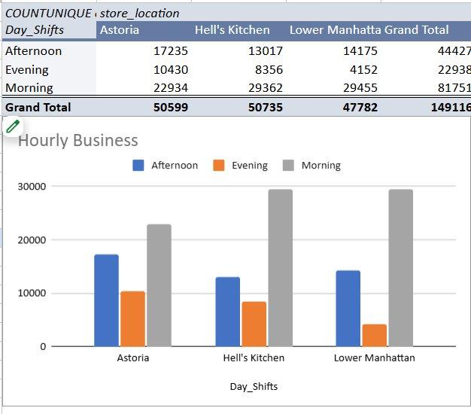
Figure 1: Excel Pivot – Transaction Count by Shift and Store Location (Hourly Busyness)

Key Observations:
- Morning is the dominant shift across all three locations with 81,751 total transactions, accounting for approximately 54.8% of all activity.
- Hell’s Kitchen leads Morning shift with 29,362 transactions, closely followed by Lower Manhattan (29,455) and Astoria (22,934).
- The Evening shift is the weakest across all stores, contributing only 22,938 transactions (15.4% of total).
- Astoria shows the most balanced distribution between Morning and Afternoon, while Hell’s Kitchen and Lower Manhattan are strongly Morning-weighted.

6.3 Revenue per Store Location (Excel Pivot)
The second pivot table analyses total revenue broken down by store location and shift, revealing not just volume but monetary contribution per operational window.

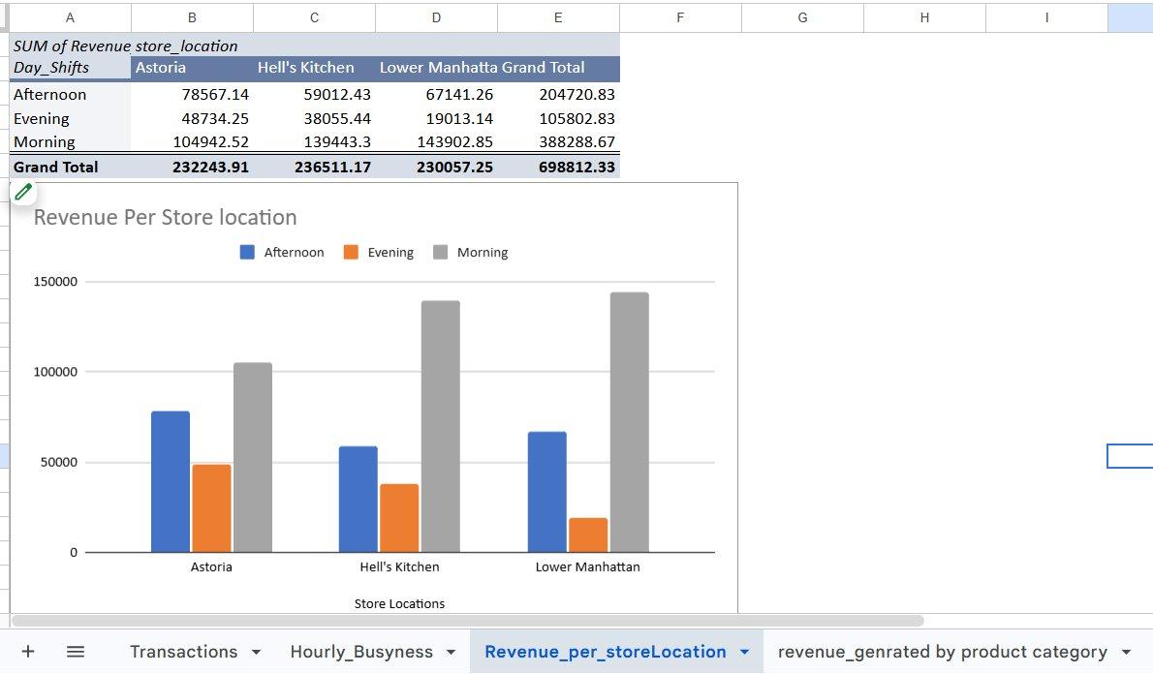
Figure 2: Excel Pivot – Revenue by Store Location and Shift

Key Observations:
- Total revenue across all stores and shifts is $698,812.33.
- Hell’s Kitchen generates the highest total revenue at $236,511.17, driven predominantly by the Morning shift ($139,443.30).
- Lower Manhattan’s Morning shift is the single largest revenue-generating window at $143,902.85.
- The Evening shift contributes the least revenue at $105,802.83 (15.1% of total), consistent with the low transaction count observed above.
- Astoria’s revenue is more evenly spread across Morning ($104,942.52) and Afternoon ($78,567.14), suggesting a different customer demographic with more midday activity.

6.4 Revenue by Product Category (Excel Pivot)
This analysis breaks down total revenue by product category to identify the highest-value menu segments.

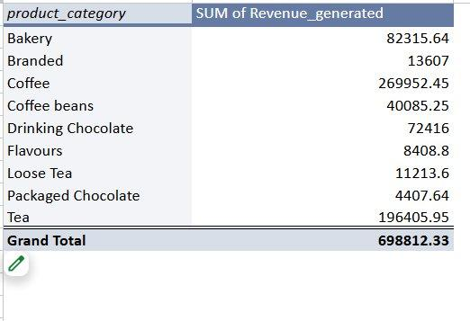
Figure 3: Excel Pivot – Revenue by Product Category

Key Observations:
- Coffee is the undisputed revenue leader at $269,952.45, representing 38.6% of total revenue.
- Tea is the second-largest category at $196,405.95 (28.1%), indicating strong non-coffee demand.
- Bakery contributes $82,315.64, making it the third most valuable category and a significant cross-sell opportunity.
- Drinking Chocolate ($72,416), Coffee Beans ($40,085.25), and Loose Tea ($11,213.60) represent meaningful but secondary revenue streams.
- Flavours ($8,408.80), Packaged Chocolate ($4,407.64), and Branded ($13,607) are the smallest segments, suggesting niche or add-on purchase behaviour.

7. SQL Analysis & Query Results

All three SQL queries were executed on Google BigQuery against the table `afficionado-coffee.afficionado_coffee.Transactions`. The queries are designed to answer specific operational questions not easily answered through pivot tables alone.

7.1 Query 1 – Revenue & Quantity by Location, Category, and Shift
Business Question:
Which store, product category, and shift combination generates the most volume and revenue?

SQL Query:
SELECT
store_location,
product_category,
SUM(transaction_qty * unit_price) AS Total_Revenue,
SUM(transaction_qty) AS total_quantity_sold,
Day_Shifts
FROM `afficionado-coffee.afficionado_coffee.Transactions`
GROUP BY product_category, store_location, Day_Shifts
ORDER BY total_quantity_sold DESC;

Query Output (Top Results):
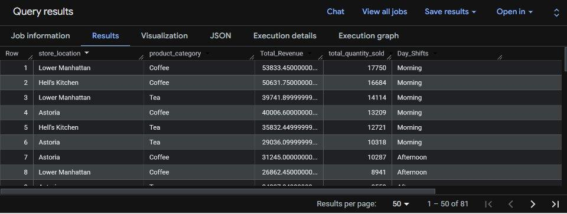
Figure 4: BigQuery Output – Revenue and Quantity by Store, Category, and Shift (Top 8 of 81 rows)

Interpretation:
- Row 1: Lower Manhattan – Coffee – Morning: 17,750 units sold, $53,833.45 revenue. The single highest-volume combination.
- Row 2: Hell’s Kitchen – Coffee – Morning: 16,684 units, $50,631.75. Second highest.
- Row 3: Lower Manhattan – Tea – Morning: 14,114 units, $39,741.90. Tea is a strong performer in the Morning shift at Lower Manhattan.
- Coffee during the Morning shift consistently dominates the top rows across all three locations, confirming the Morning + Coffee combination as the primary revenue engine.
- The query returns 81 rows in total, covering all unique store × category × shift combinations, providing a comprehensive revenue matrix for operational planning.

7.2 Query 2 – Hourly Foot Traffic per Store
Business Question:
Which hours generate the most customer visits at each location, and what is the average basket size per hour?

SQL Query:
SELECT
store_location,
EXTRACT(HOUR FROM TIME(transaction_time)) AS hour_of_day,
COUNT(DISTINCT transaction_id) AS total_customer_foot_traffic,
ROUND(SUM(transaction_qty) /
COUNT(DISTINCT transaction_id), 2) AS avg_items_per_customer
FROM `afficionado-coffee.afficionado_coffee.Transactions`
GROUP BY store_location, hour_of_day
ORDER BY total_customer_foot_traffic DESC;

Query Output (Top Results):
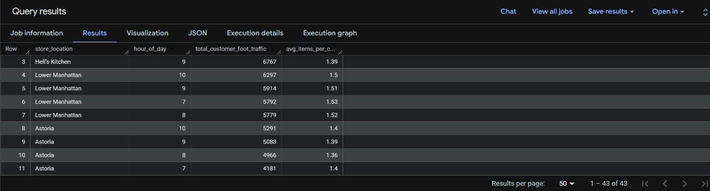
Figure 5: BigQuery Output – Hourly Foot Traffic and Avg Items per Customer (Top rows of 43 total)

Interpretation:
- Hell’s Kitchen at 9:00 AM records the highest hourly foot traffic with 6,767 unique transactions.
- Lower Manhattan at hours 10:00 (6,297), 9:00 (5,914), 7:00 (5,792), and 8:00 (5,779) all rank in the top 7, confirming an extended morning rush at this location.
- Astoria’s peak is at 10:00 AM (5,291 transactions), slightly later than the other two locations.
- Average items per customer ranges from 1.36 to 1.53, indicating most customers purchase 1–2 items per visit. Lower Manhattan customers average slightly higher basket sizes (1.50–1.53) compared to Astoria (1.36–1.40).
- The 43-row result set covers all active hour–store combinations, enabling precise staffing timetables.

7.3 Query 3 – Price Tier Analysis by Product Category
Business Question:
How do Budget, Standard, and Premium price tiers perform in terms of order count and units sold across product categories?

SQL Query:
SELECT
product_category,
CASE
WHEN unit_price < 2.00 THEN 'Budget (< $2)'
WHEN unit_price BETWEEN 2.00
AND 4.50 THEN 'Standard ($2-$4.5)'
ELSE 'Premium (> $4.5)'
END AS price_tier,
COUNT(DISTINCT transaction_id) AS total_orders,
SUM(transaction_qty) AS total_units_sold
FROM `afficionado-coffee.afficionado_coffee.Transactions`
GROUP BY product_category, price_tier
ORDER BY total_units_sold DESC;

Query Output:
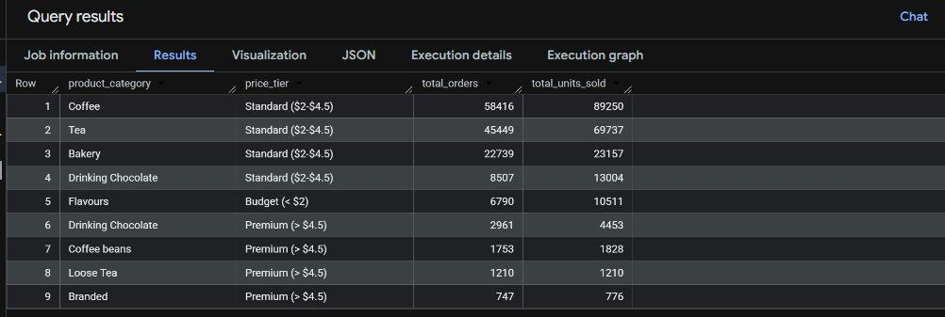
Figure 6: BigQuery Output – Price Tier Performance by Product Category

Interpretation:
- Coffee – Standard tier ($2–$4.50) dominates with 89,250 units sold across 58,416 orders. This is the single largest segment in the entire product portfolio.
- Tea – Standard tier is second with 69,737 units sold (45,449 orders), confirming Standard pricing as the sweet spot for volume-driving beverages.
- Bakery – Standard tier contributes 23,157 units across 22,739 orders, indicating bakery items are near-uniform in pricing and drive strong repeat purchase behaviour.
- Drinking Chocolate splits across Standard (13,004 units) and Premium (4,453 units) tiers, showing dual-tier demand.
- Flavours fall in the Budget tier with 10,511 units — these are likely flavour shots/add-ons priced below $2.00.
- Premium items (Coffee Beans, Loose Tea, Branded) have significantly lower unit volumes (776–1,828), confirming they serve a niche high-value segment rather than the mass market.

8. Key Findings & Insights

Finding 1: Morning Shift is the Dominant Revenue Window
The Morning shift (6:00–11:00 AM) generates $388,288.67 in revenue, representing 55.6% of total annual revenue. It also handles 81,751 transactions (54.8% of all transactions). This is consistent across all three locations, driven by commuter and pre-work coffee demand. The Morning shift should be treated as the critical operational window.

Finding 2: Coffee + Tea = 66.7% of All Revenue
Coffee ($269,952.45) and Tea ($196,405.95) together account for $466,358.40, or 66.7% of total revenue. Standard-priced beverages ($2–$4.50) dominate in both order count and volume, confirming that accessible pricing drives the core business. Premium beverages exist but serve a smaller segment.

Finding 3: Peak Hour is 9:00 AM – 10:00 AM Across All Locations
SQL Query 2 confirms that the 9:00–10:00 AM window generates the highest foot traffic at every location. Hell’s Kitchen peaks at 9:00 AM (6,767 transactions), Lower Manhattan peaks at 10:00 AM (6,297), and Astoria peaks at 10:00 AM (5,291). This one-hour offset suggests Lower Manhattan and Astoria serve a slightly later commuter wave, likely tied to office start times in those neighbourhoods.

Finding 4: Lower Manhattan Has the Highest Basket Size
Despite Hell’s Kitchen having the highest total revenue, Lower Manhattan customers average 1.50–1.53 items per transaction compared to Astoria’s 1.36–1.40. This suggests Lower Manhattan’s customer base, likely corporate office workers, tends to buy for colleagues or add food items alongside beverages, presenting a strong upselling opportunity.

Finding 5: Evening Shift is Significantly Underperforming
The Evening shift (17:00–21:00) generates only $105,802.83 in revenue (15.1% of total) and 22,938 transactions. Lower Manhattan’s Evening performance is especially weak ($19,013.14), likely because the corporate population has left the area by early evening. Astoria’s Evening shift is relatively stronger, suggesting a residential neighbourhood with more consistent evening demand.

Finding 6: Bakery is a High-Frequency Cross-Sell Category
Bakery ranks third in revenue ($82,315.64) and third in standard-tier units sold (23,157 items). With 22,739 orders, almost every bakery sale is a single-unit transaction, indicating it is consistently purchased alongside a beverage. This high attach rate makes bakery the most important cross-sell category in the portfolio.

9. Operational Recommendations

Recommendation 1: Staff Maximally During 8:00–11:00 AM
Across all stores, the 8:00–11:00 AM window is the peak demand period. Schedule at least two baristas plus a dedicated POS operator during this window to minimise queue times and maximise throughput. Hell’s Kitchen should be fully staffed by 8:30 AM given its earlier peak.

Recommendation 2: Reduce Evening Staffing at Lower Manhattan
Lower Manhattan’s Evening shift generates only $19,013.14 — the weakest single shift-location combination in the dataset. Consider reducing to a skeleton crew of one barista after 17:00 at this location to optimise labour cost without significant revenue impact.

Recommendation 3: Promote Bakery as a Morning Bundle
With bakery contributing $82,315.64 at high transaction frequency, create a Morning Bundle promotion (e.g., “Coffee + Pastry for $X”) to increase average order value during the already-busy Morning shift. Even a 10% increase in bakery attach rate during Morning hours could yield an estimated $8,000+ in incremental annual revenue.

Recommendation 4: Upsell Premium Products at Lower Manhattan
Lower Manhattan’s higher-than-average basket size (1.50–1.53 items) and corporate customer base make it the ideal location to introduce or prominently feature premium-tier products (Coffee Beans, Loose Tea, Branded merchandise). These categories currently represent only a small share of revenue but have disproportionate margin potential.

Recommendation 5: Target Astoria’s Afternoon Cohort with Promotions
Astoria shows a more balanced Morning-Afternoon split compared to other locations. An Afternoon Happy Hour promotion (e.g., 13:00–15:00) targeting the residential and local freelancer demographic could convert Astoria’s already-solid Afternoon traffic ($78,567.14) into the highest-revenue Afternoon window across all stores.

10. Conclusion

This report provides a comprehensive, evidence-based understanding of sales patterns at Afficionado Coffee Roasters across its three New York City locations. Through a multi-layered analytical approach — combining Excel pivot analysis, Google BigQuery SQL queries, and an interactive Streamlit dashboard — clear and actionable temporal demand insights have been uncovered.

The Morning shift (6:00–11:00 AM) is the undisputed engine of the business, generating 55.6% of total revenue. Coffee and Tea together account for two-thirds of all income. Peak foot traffic consistently occurs between 9:00 and 10:00 AM across all stores, with store-specific timing differences reflecting local commuter demographics. The Evening shift is structurally weak, particularly at Lower Manhattan.

Armed with these findings, Afficionado Coffee Roasters’ management can move from intuition-driven scheduling to precision staffing, introduce targeted bundling and upselling campaigns, and allocate operational resources more efficiently — ultimately improving both customer experience and profitability.

End of Report
Afficionado Coffee Roasters · Sales Trend & Time-Based Performance Analysis · 2026

